GlassRx

User Guide

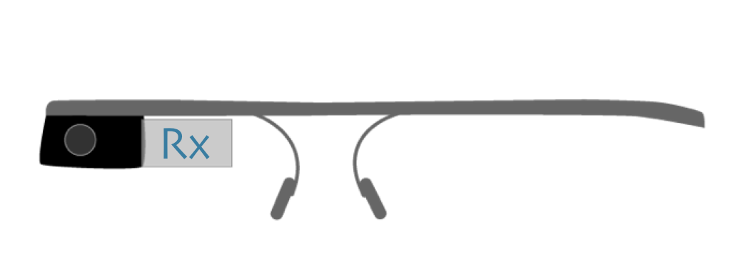

# Introduction

Welcome to the GlaxxRx mobile application. This guide is designed to acquaint the user with the basic functions of the application for viewing medication schedules and receiving alerts created via the AndroidRx companion app. The following is divided into two sections: one highlights the navigations and functionality of the app from a provider perspective, and the other explores the patient-side feature set.

# Provider

GlassRx allows for providers view their list of patients and each patient’s basic information and pill schedule. Each screen is navigable both by voice commands and with touch gestures to allow flexibility for situational use.

To log in as a provider, simply choose the “I am a provider” option when you open the GlassRx app. This can be achieved by either activating the voice menu by saying “OK Glass”, or by *tapping* on the device to activate the gesture menu, where you can *swipe* left or right through your options and tap to select.

Currently, you are automatically logged in to the default provider account “rs123” with corresponding password “ryanshaw”. Future versions will include the ability to enter an account, or log you in to your own account based on the Google account linked to your glass device.

Upon logging in, you will be relocated to a list of your currently assigned patients. You can scroll through these, and choose an option with either voice or gesture activation, as before.

Once you’ve selected a patient from your patient list, you will be directed to his or her profile. This page displays some basic information about the patient, as well as the list of medications they are currently assigned.

## 

## Patient

You can view the patient side of the GlassRx app by selecting the “I’m a patient” option when you open the application. Currently, you are automatically logged in to the default provider account “vw22” with corresponding password “vincentwang”. Future versions will include the ability to enter an account, or log you in to your own account based on the Google account linked to your glass device.

This will create a *Live Card* that will contain your information about the next medication you are scheduled to take. This card is persistent, meaning it will exist until you destroy it. It can be navigated to by swiping through all of your Live Cards, such as your settings Live Card, and thus is reachable without having to open the app itself.

This live card contains information about the next medication you are scheduled to take, namely the time you are scheduled to take it. You can go further by activating the menu on the live card (either with voice activation via an “OK Glass” command, or a gesture command, i.e. *tapping*). This menu will give you the option of viewing your entire list of medications, or getting more information about your next scheduled medication.

From the medication list, you can again choose any of these medications through voice or gesture menus, which will lead you to the more information page about that medication.

When it is time to take one of your scheduled medications, an audible alarm will go off and you will be redirected to the Live Card with the relevant information. After a short amount of time, the card will automatically update itself with information about your next scheduled medication.